*Uses various Chi-Square and ANOVA tests to solve different types of problems*

**Assignment**

**2**

A2

ALY6015 Intermediate Analytics

Assignment 2 – Chi-Square Testing & ANOVA

**PREPERATION:**

By: John DiSessa

For: Professor Goulding

On: October 10th, 2021

**Introduction**

This report analyzes the 8 questions from assignment 2 using Chi-Square goodness of fit, Chi-Square independence, one-way ANOVA, two-way ANOVA, Scheffe Tests, Tukey Tests, and interaction plots.

**Section 11.1**

**Blood Types**

*Hypothesis and Claim:*

The blood type distribution for our sample is the same as the population.

H0: A = .20, B = .28, O = .36, AB = .16

Ha: Our distribution is different from the population distribution

*Critical Value:*

The critical value of 6.251 was calculated from the Chi-Square Distribution table with 3 degrees of freedom and α = .1.

*Test Value:*

Chi-Square Goodness of Fit

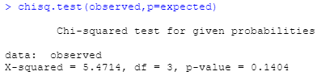

*Decision:*

Since our Chi-Square value of 5.47 is less than our critical value of 6.251, we fail to reject the null hypothesis. We also fail to reject the null since our p-value of .14 is greater than our alpha of .10.

*Summary:*

Since we failed to reject the null hypothesis that our sample distribution is equal to the population distribution at a .10 significance level, we can say that our distribution is the same as the population distribution.

**On-Time Performance by Airlines**

*Hypothesis and Claim:*

The airline performance for our random sample is the same as the population (Bureau of Transportation Statistics)

H0: On-Time = .708, National Aviation System Delay = .082, Aircraft Arriving Late = .090, Other = .120

Ha: Our distribution is different from the population distribution

*Critical Value:*

The critical value of 7.815 was calculated from the Chi-Square Distribution table with 3 degrees of freedom and α = .05.

*Test Value:*

Chi-Square Goodness of Fit

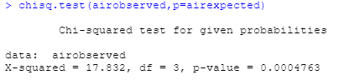

*Decision:*

Since our Chi-Square value of 17.832 is greater than our critical value of 7.815, we reject the null hypothesis in favor of the alternative hypothesis. Also, since our p-value is less than our alpha, we also reject the null hypothesis.

*Summary:*

Since we rejected the null hypothesis, we conclude that our sample’s on-time performance differs from the population distribution.

**Section 11-2**

**Ethnicity and Movie Admissions**

*Hypothesis and Claim:*

Movie admissions are related to ethnicity.

H0: Movie admissions are independent of ethnicity

Ha: Movie admissions are dependent of ethnicity

*Critical Value:*

The critical value of 7.815 was calculated from the Chi-Square Distribution table with 3 degrees of freedom and α = .05.

*Test Value:*

Chi-Square Test of Independence

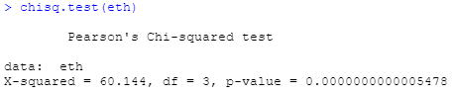

*Decision:*

Since our Chi-Square value of 60.144 is greater than our critical value of 7.815, we reject the null hypothesis in favor of the alternative hypothesis. Also, since our p-value is less than our alpha, we also reject the null hypothesis.

*Summary:*

Since we rejected the null hypothesis in favor of the alternative hypothesis, we can conclude that movie admissions and ethnicity are dependent.

**Women in the Military**

*Hypothesis and Claim:*

Rank is related to Branch in the Armed Forces.

H0: Rank and Branch are independent variables

Ha: Rank and Branch are dependent variables

*Critical Value:*

The critical value of 7.815 was calculated from the Chi-Square Distribution table with 3 degrees of freedom and α = .05.

*Test Value:*

Chi-Square Test of Independence

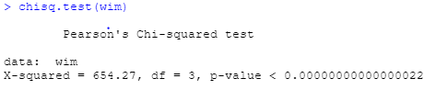

*Decision:*

Since our Chi-Square value of 654.27 is greater than our critical value of 7.815, we reject the null hypothesis in favor of the alternative hypothesis. Also, since our p-value is less than our alpha, we also reject the null hypothesis.

*Summary:*

Since we rejected the null hypothesis, we can conclude that Rank is related to Branch in the Armed Forces.

**Section 12-1**

**Sodium Contents of Food**

*Hypothesis and Claim:*

The mean amount of sodium (in milligrams) is the same between Condiments, Cereals, and Desserts.

H0: µ Condiments = µ Cereals = µ Desserts

Ha: At least one of the means differs from the others

*Critical Value:*

The Critical F Value of 3.52 was calculated by:

* the degrees of freedom of 2 between the 3 groups (numerator or k-1)
* the degrees of freedom of 19 within groups (denominator or N-k).
* α = .05
* N = sample size of 22. K = number of groups of 3.

*Test Value:*

One-Way ANOVA



*Decision:*

Since our F statistic of 2.399 is less than our critical value, we fail to reject the null hypothesis. Since our p-value of .118 is greater than our alpha, we also fail to reject the null hypothesis.

*Summary:*

Since our null is not rejected, we can conclude that mean sodium values of Condiments, Cereals, and Desserts are equal. Since there are no differences in means, the Scheffe test can’t show us which means differ from each other.

**Section 12-2**

**Sales for Leading Companies**

*Hypothesis and Claim:*

There is a significant difference in mean sales between at least one company.

H0: µ Cereal = µ Chocolate Candy = µ Coffee

Ha: At least one of the means differs from the others

*Critical Value:*

The Critical F Value of 7.21 was calculated by:

* the degrees of freedom of 2 between the 3 groups (numerator or k-1)
* the degrees of freedom of 11 within groups (denominator or N-k).
* α = .01
* N = sample size of 14. K = number of groups of 3.

*Test Value:*

One-Way ANOVA



*Decision:*

Since our F statistic of 2.17 is less than our critical value, we fail to reject the null hypothesis. Since our p-value of .16 is greater than our alpha, we also fail to reject the null hypothesis.

*Summary:*

Since our null is not rejected, we can conclude that mean sales values of Cereal, Chocolate Candy, and Coffee are equal. Since there are no differences in means, the Scheffe test can’t show us which means differ from each other.

**Per-Pupil Expenditures**

*Hypothesis and Claim:*

The mean amount of expenditures (in dollars) is the same between the three sections of the country.

H0: µ East = µ Middle = µ West

Ha: At least one of the means differs from the others

*Critical Value:*

The Critical F Value of 4.10 was calculated by:

* the degrees of freedom of 2 between the 3 groups (numerator or k-1)
* the degrees of freedom of 10 within groups (denominator or N-k).
* α = .05
* N = sample size of 13. K = number of groups of 3.

*Test Value:*

One-Way ANOVA



*Decision:*

Since our F statistic of .649 is less than our critical value, we fail to reject the null hypothesis. Since our p-value of .16 is greater than our alpha, we also fail to reject the null hypothesis.

*Summary:*

Since our null is not rejected, we can conclude that mean expenditure amounts in the Eastern third, Middle third, and Western third of the US are equal. Since there are no differences in means, the Scheffe test can’t show us which means differ from each other.

**Section 12-3**

**Increasing Plant Growth**

*Hypotheses and Claims:*

Claim 1: Is there a difference in mean growth with respect to light? (α= .05)

H0: µ Light 1 = µ Light 2

Ha: µ Light 1 ≠ µ Light 2

Claim 2: Is there a difference in mean growth with respect to plant food? (α= .05)

H0: µ Food A = µ Food B

Ha: µ Food A ≠ µ Food B

Claim 3: Is there any interaction between light and plant food? (α= .05)

H0: No interaction between light and food

Ha: Interaction between light and food

*Critical Values:*

The Critical F Value of 5.32 for all three claims was calculated by:

* the degrees of freedom of 1 between the 2 Light groups (numerator or a-1 or A)
* the degrees of freedom of 1 between the 2 Food groups (numerator or b-1 or B)
* the degrees of freedom of 1 for interaction between Light and Food (A*B = 1*1)
* the degrees of freedom of 8 within groups (denominator or (N-1)*a*b = (3-1)*2*2)
* α = .05
* N = number of values in each group = 3
* A = 1, a = 2, B = 1, b = 2
  + Light has 2 levels and Food has 2 levels

*Test Values:*

Two-Way ANOVA

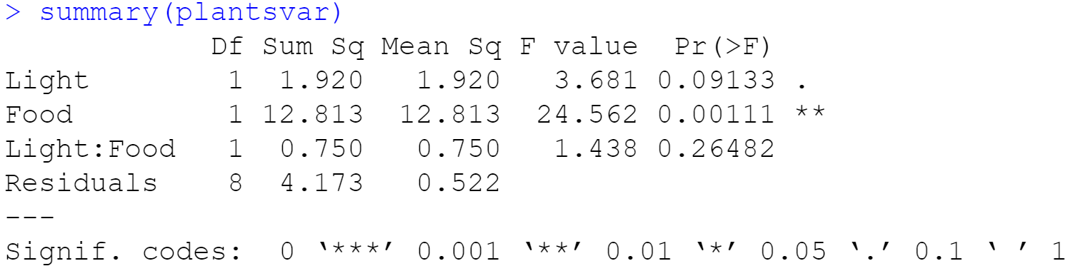

*Decisions:*

Claim 1: Our F statistic of 3.681 is less than our critical value of 5.32 and our p-value of .09 is greater than our alpha of .05. We fail to reject the null hypothesis.

Claim 2: Our F statistic of 24.562 is greater than our critical value of 5.32 and our p-value of .001 is less than our alpha of .05. We reject the null hypothesis.

Claim 3: Our F statistic of 1.438 is less than our critical value of 5.32 and our p-value of .26 is greater than our alpha of .05. However, we also need to graph their interaction to confirm that we fail to reject the null hypothesis.

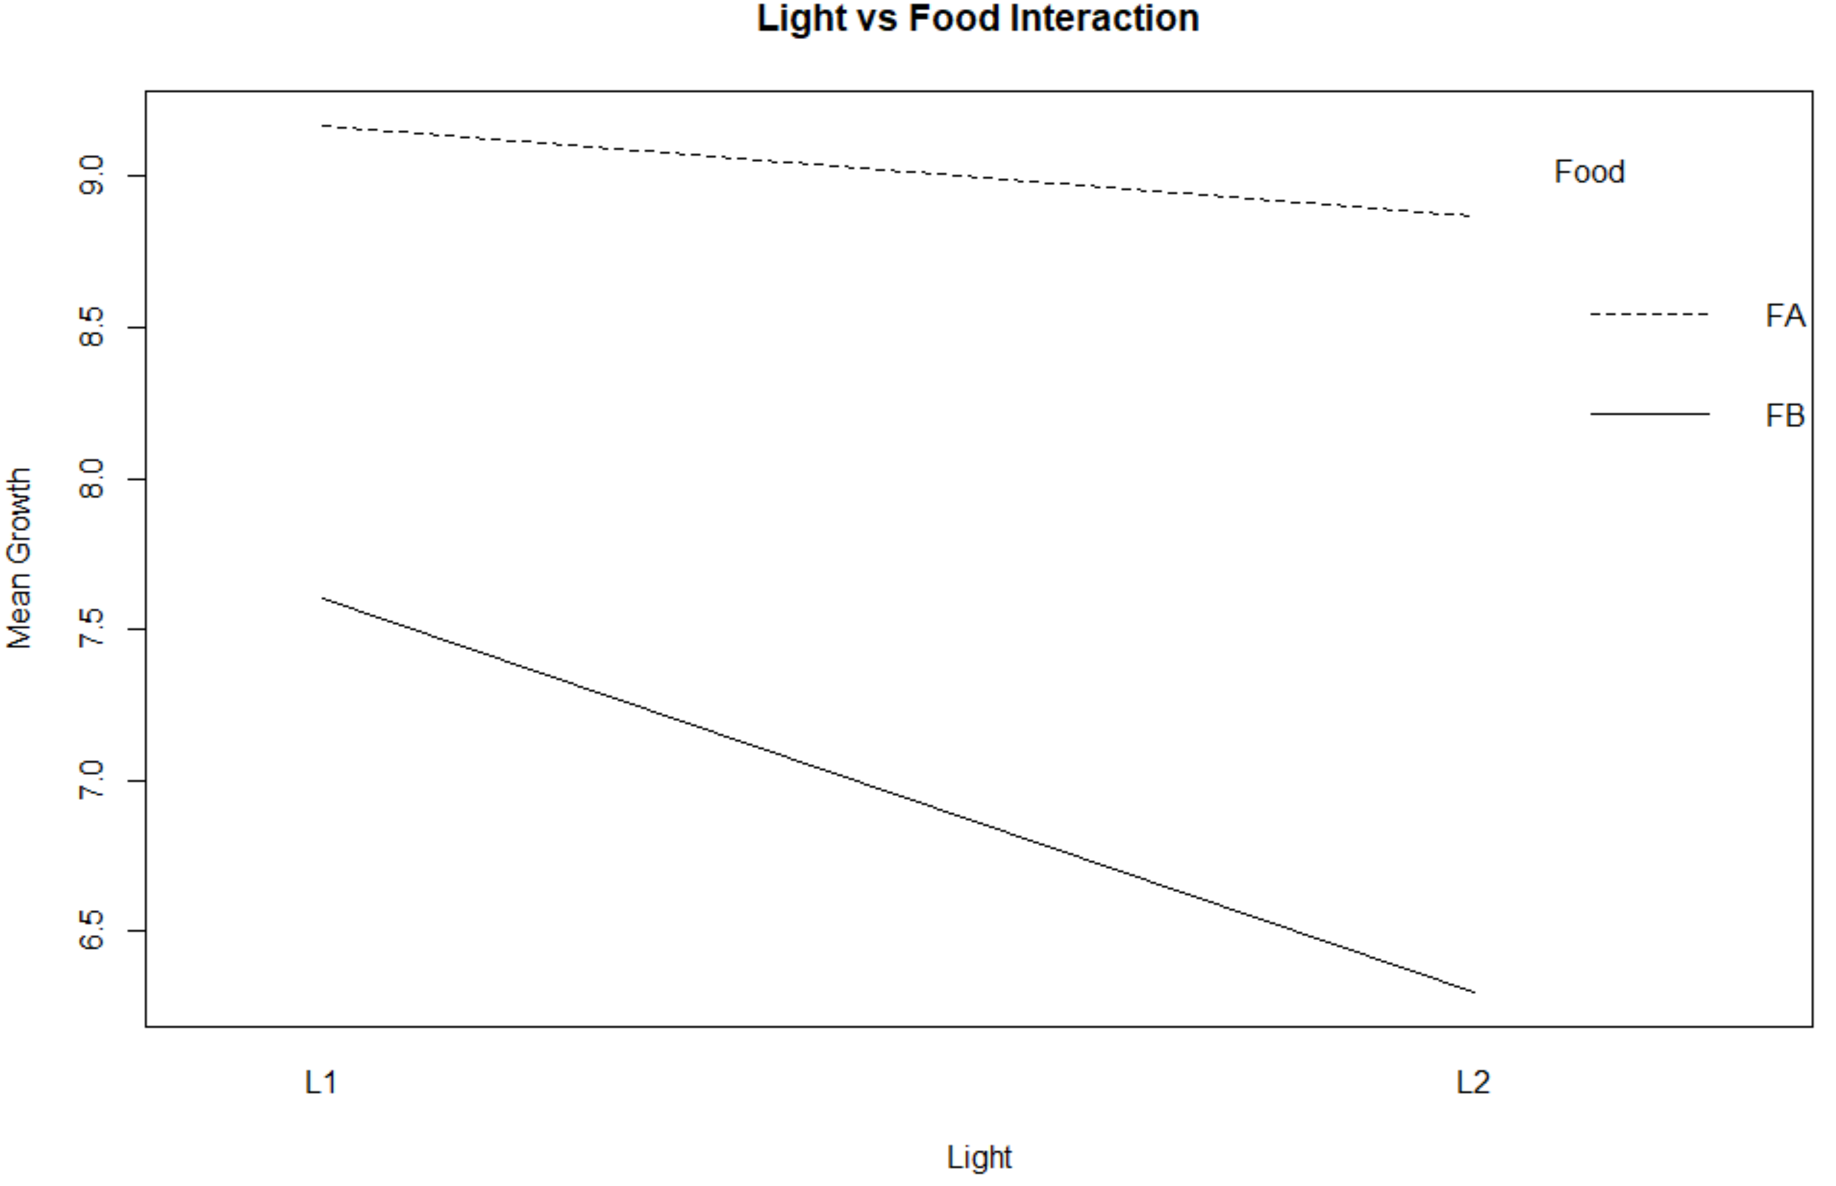

Since the two lines are not parallel and do not cross each other, we have an ordinal interaction. Growth is independent of both Light and Food. Also, the predicted growth results for Food A subjects are always higher than the predicted growth results of Food B subjects. If the lines were parallel, there would be no interaction.

*Summary:*

Since we failed to reject the nulls for claims 1 and 3, we can conclude that the mean growths of plants with Light 1 and 2 are not different and there is no interaction between Light and Food. We rejected the null of claim 2 so we determined that the mean growths of plants with Food A and B are different.

**Section 9**

**Baseball**

*Step 1:* Import the baseball.csv data in R

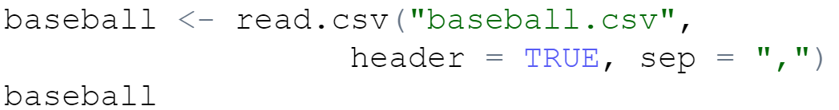

*Step 2:* Exploratory Data Analysis

I slightly modified the dataset to make all the variables numeric in order to create a correlation matrix. I also added a variable RD (Run Differential = Runs Scored – Runs Allowed). From my pervious knowledge of baseball, I know that teams can win by outscoring opponents or limiting opponents runs (offense vs defense debate). The best teams, however, can do both. Unsurprisingly, Run Differential is very strongly positively correlated with Wins at .94. The more teams increase their run differential, the more games they win.

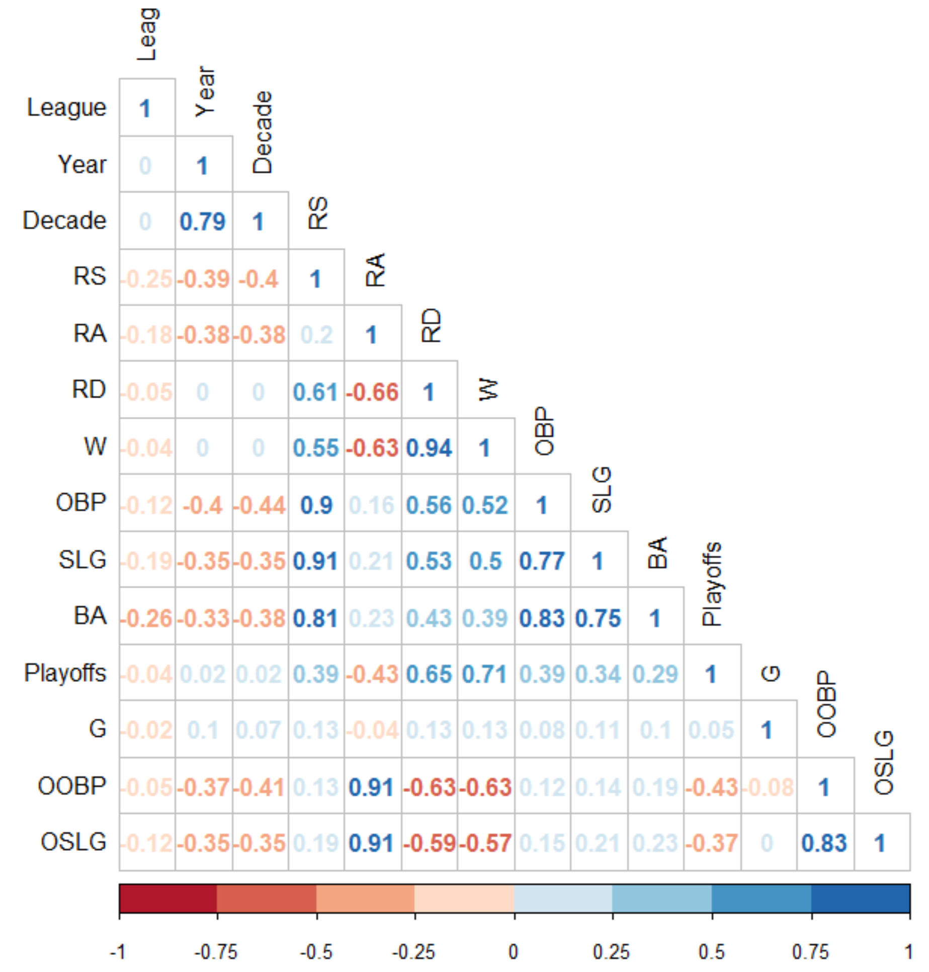

I then created a histogram chart to plot out all team’s wins in each season. The average team won about 81 games each season. Since there are 162 games in a season, the average team would have exactly a .500 winning percentage. Based on the histogram, Wins looks normally distributed or maybe marginally left skewed.

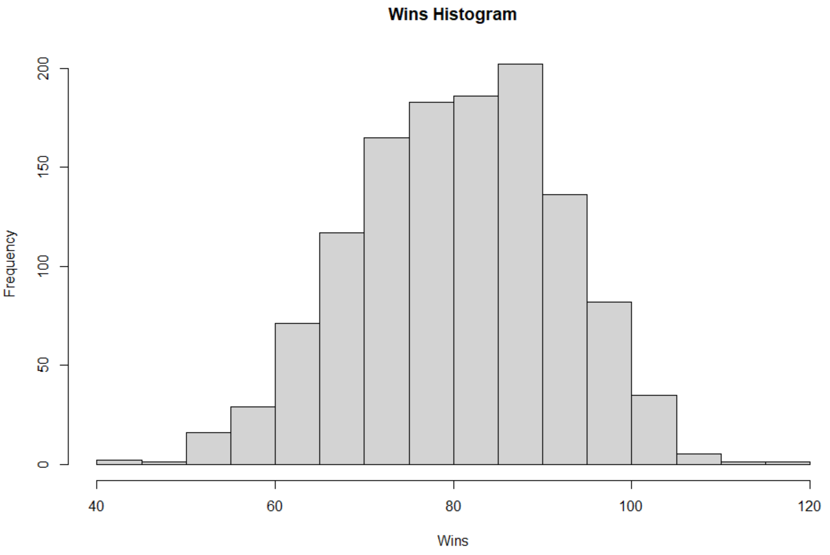

Lastly, I quickly compared Wins by league (AL vs NL) to see if one league has an advantage. Since teams in the AL mostly play other AL teams, there is very little AL vs NL cross-over so it is not surprising to see their mean wins be equal.

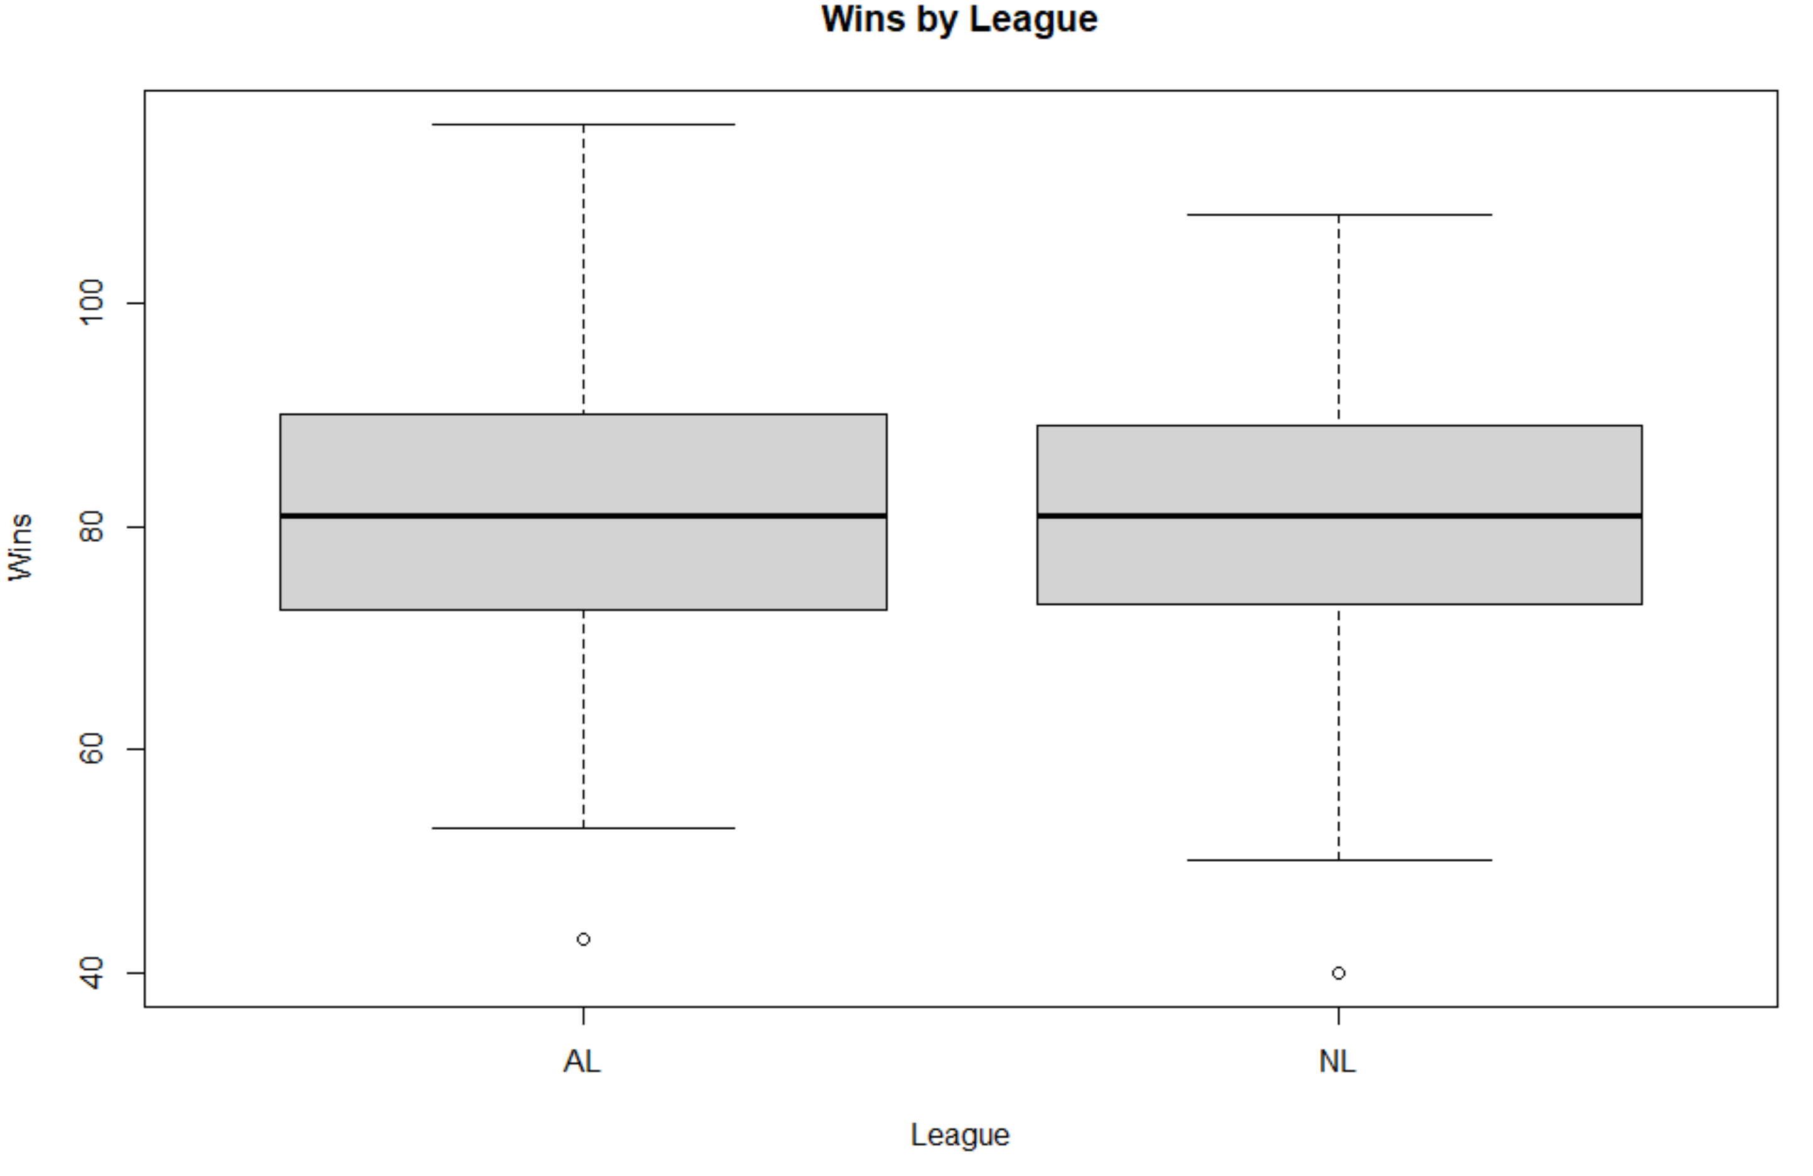

Our dataset contains data on each team between 1962 and 2012.

*Step 3: Wins by Decade:*

I quickly created a table (wintable) to count the total number of wins by decade. The 2010s and 1960s have the least amount of wins, but that can be partially explained by the sample size in each decade, as seen by the second table.

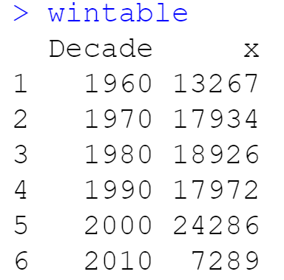 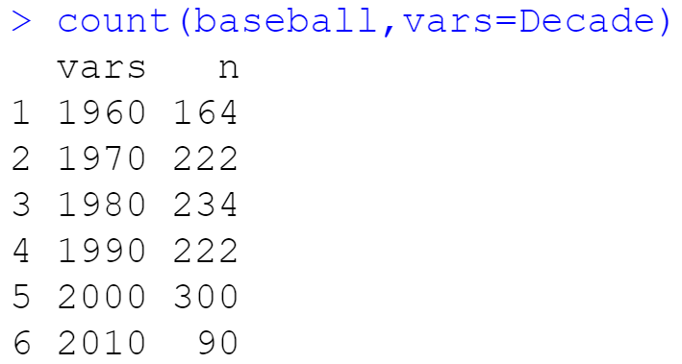

Hypothesis and Claim:

H0: Win distribution is evenly spread evenly across decades

Ha: Win distribution is evenly spread unevenly across decades

Critical Value:

The critical value of 11.07 was calculated from the Chi-Square Distribution table with 5 (N-1) degrees of freedom and α = .05.

Test Value:

Chi-Square Goodness of Fit

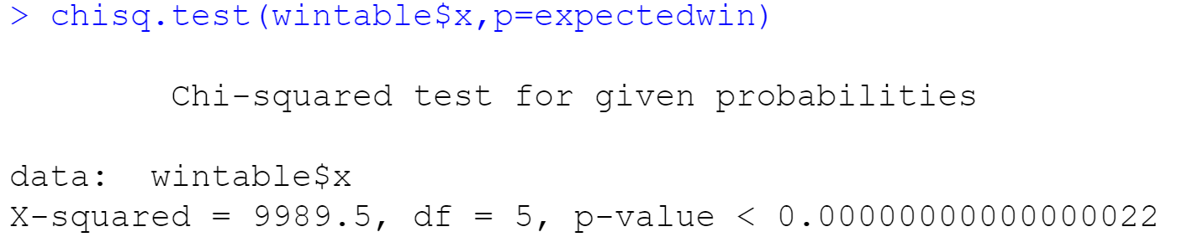

Decision:

Since our Chi-Square value of 9989.5 is more than our critical value of 11.07, we reject the null hypothesis. We also reject the null since our p-value is less than our alpha of .05.

Summary:

Since we rejected the null hypothesis, we can conclude that our wins are not evenly distributed by decade. If they were evenly distributed, we would have expected to see 1/6 of the total wins in each decade, or about 16,612.

**Crops**

*Step 4:* Import the crop_data.csv data in R

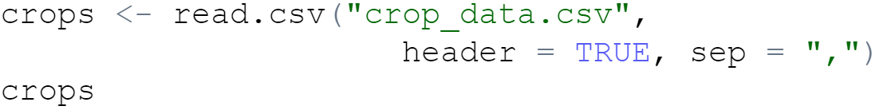

*Step 5:* Fertilizer and Density impacts Yield

Hypotheses and Claims:

Claim 1: Is there a difference in mean yield with respect to fertilizer? (α= .05)

H0: µ Fertilizer 1 = µ Fertilizer 2 = µ Fertilizer 3

Ha: µ Fertilizer 1 ≠ µ Fertilizer 2 ≠ µ Fertilizer 3

Claim 2: Is there a difference in mean yield with respect to density? (α= .05)

H0: µ Density 1 = µ Density 2

Ha: µ Density 1 ≠ µ Density 2

Claim 3: Is there any interaction between fertilizer and density? (α= .05)

H0: No interaction between fertilizer and density

Ha: Interaction between fertilizer and density

Critical Value:

The Critical F Values

* Fertilizer = 3.097
* Density = 3.947
* Interaction = 3.097

Degrees of Freedom

* the degrees of freedom of 2 between the 3 Fertilizer groups (numerator or a-1 or A)
* the degrees of freedom of 1 between the 2 Density groups (numerator or b-1 or B)
* the degrees of freedom of 2 for interaction between Light and Food (A*B = 2*1)
* the degrees of freedom of 90 within groups (denominator or (N-1)*a*b = (16-1)*3*2)
* α = .05
* N = number of values in each group = 16
* A = 2, a = 3, B = 1, b = 2
  + Fertilizer has 3 levels and Density has 2 levels

Test Values:

Two-Way ANOVA

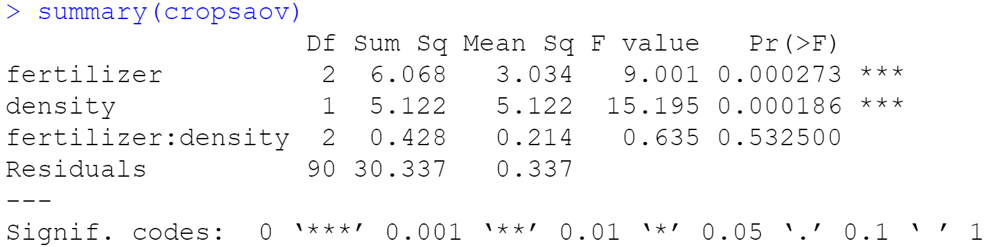

Decisions:

Claim 1: Our F statistic of 9.001 is greater than our critical value of 3.097 and our p-value is less than our alpha of .05. We reject the null hypothesis.

Claim 2: Our F statistic of 15.195 is greater than our critical value of 3.947 and our p-value is less than our alpha of .05. We reject the null hypothesis.

Claim 3: Our F statistic of .635 is less than our critical value of 3.097 and our p-value of .51 is greater than our alpha of .05. However, we also need to graph their interaction to confirm that we fail to reject the null hypothesis. Since the two lines are not parallel and do not cross each other, we have an ordinal interaction. Yield is independent of both Fertilizer and Density. If the lines were parallel, there would be no interaction.

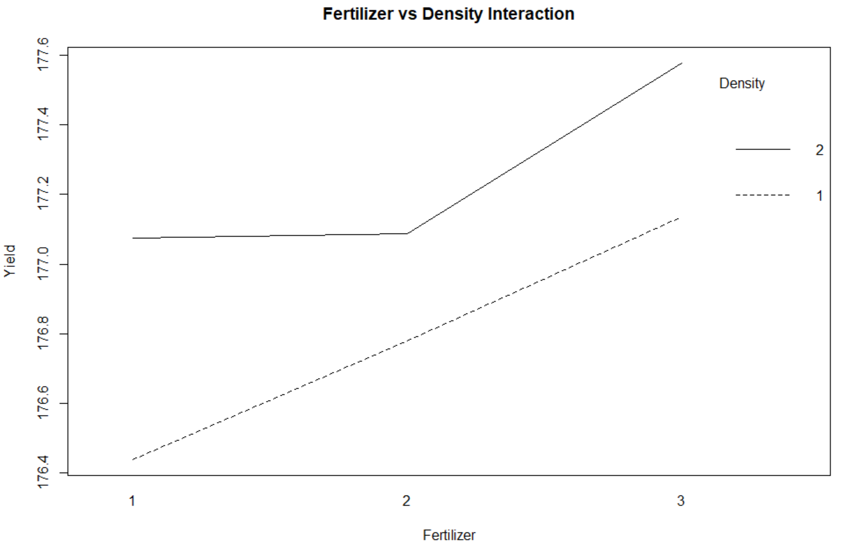

I also ran a Tukey test to see exactly which pairs of mean Yield for Fertilizers were different. Since the p-value of the 3-1 pair is less than .05, we can conclude that the Yields from Fertilizer 1 and 3 and actually different.

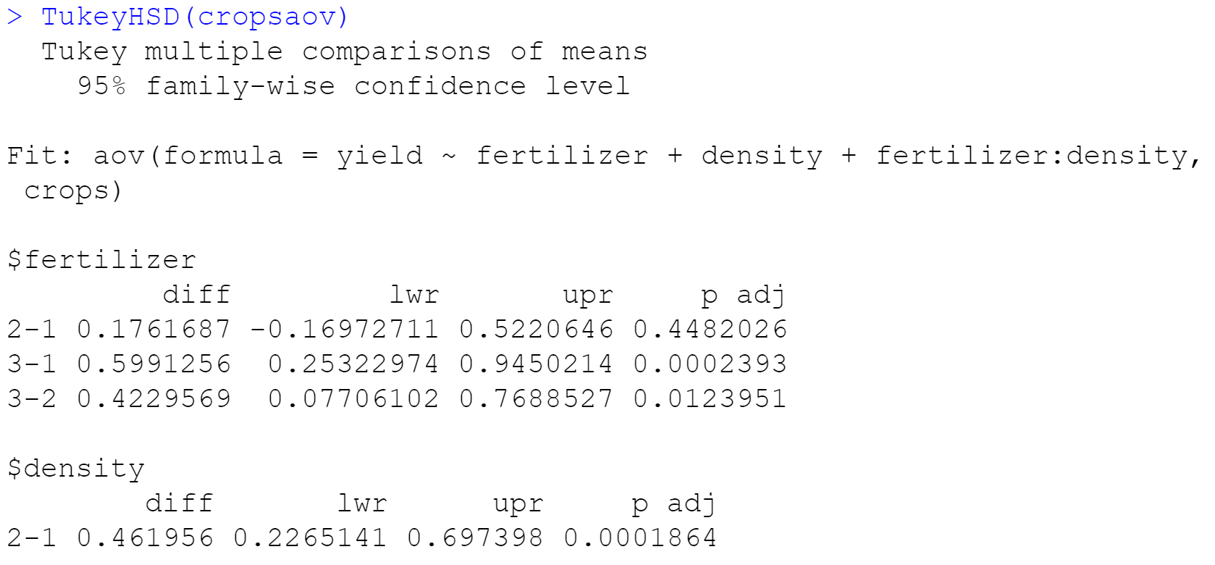

Summary:

Since we rejected the null hypothesis for Claim 1, we can say that the mean Yield for each type of Fertilizer is different. Since we rejected the null hypothesis for Claim 2, we can say that the mean Yield for each type of Density is different. We failed to reject the null hypothesis for Claim 3 so we can say that there is no interaction between Fertilizer and Density.

**Summary**

After conducting Chi-Square, Scheffe, Tukey, One-Way ANOVA, and Two-Way ANOVA tests and creating interaction plots, I demonstrated the ability to properly compare the means of different groups and the influential factors around them.

Summary of our results from Assignment 2:

* Our distribution of blood type is the same as the population
* Our sample’s on-time performance differs from the Bureau of Transportation Statistics
* Movie admissions is dependent on ethnicity
* Rank is related to Branch in the Armed Forces
* The mean sodium values of Condiments, Cereals, and Desserts are equal
* The mean sales values of Cereal, Chocolate Candy, and Coffee are equal
* The mean expenditure amounts in the Eastern third, Middle third, and Western third of the US are equal
* The mean growths of plants with Light 1 and 2 are not different. There is no interaction between Light and Food. The mean growths of plants with Food A and B are different.
* Our baseball wins are not evenly distributed by decade
* The mean Yield for each type of Fertilizer is different. The mean Yield for each type of Density is different. There is no interaction between Fertilizer and Density.

**Scheffe Tests**

Not presented due to lack of significance

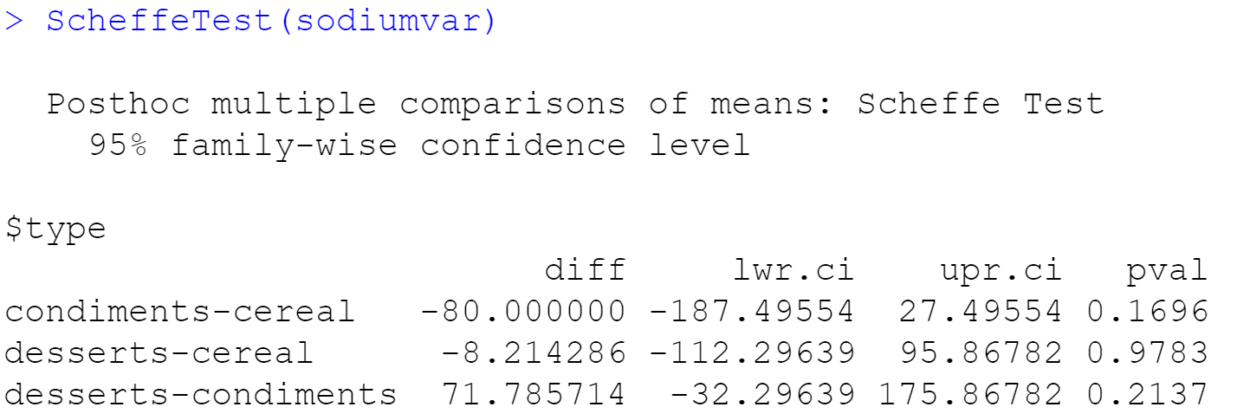

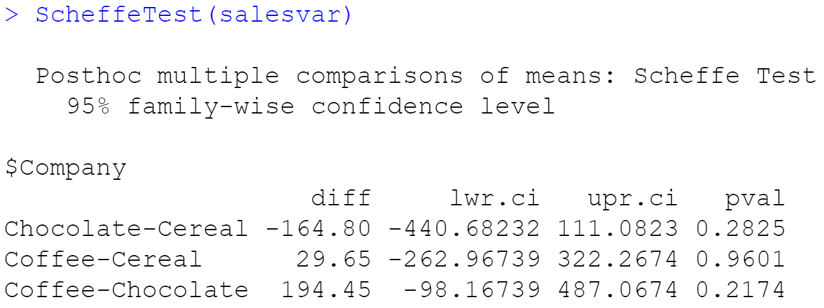

**Citations**

“Chi-Squared Test of Independence.” *Chi-Squared Test of Independence | R Tutorial*, http://www.r-tutor.com/elementary-statistics/goodness-fit/chi-squared-test-independence.

“What If the P-Value Is Less than 0.05, but the Test Statistic Is Also Less than the Critical Value?” *Cross Validated*, 1 Mar. 1969, https://stats.stackexchange.com/questions/498077/what-if-the-p-value-is-less-than-0-05-but-the-test-statistic-is-also-less-than.

“P Value from Chi-Square Calculator.” *Quick P Value from Chi-Square Score Calculator*, https://www.socscistatistics.com/pvalues/chidistribution.aspx.

Zach. “How to Read the Chi-Square Distribution Table.” *Statology*, 2 June 2021, https://www.statology.org/how-to-read-chi-square-distribution-table/.

“Data Frames.” *R*, https://www.tutorialspoint.com/r/r_data_frames.htm.

“The F-Distribution in R.” *The F-Distribution in R • SOGA •*, 17 Feb. 2017, https://www.geo.fu-berlin.de/en/v/soga/Basics-of-statistics/Continous-Random-Variables/F-Distribution/F-Distribution-in-R/index.html.

*Notes 9C: Two-Way ANOVA with Interactions 1. What Is an ...* http://www.bwgriffin.com/gsu/courses/edur8132/notes/Notes9c_ANOVAWithInteractions.pdf.

“One-Way ANOVA Test in R.” *STHDA*, http://www.sthda.com/english/wiki/one-way-anova-test-in-r.

“Two-Way ANOVA Test in R.” *STHDA*, http://www.sthda.com/english/wiki/two-way-anova-test-in-r.

“Two-Way ANOVA Test in R.” *STHDA*, http://www.sthda.com/english/wiki/two-way-anova-test-in-r.

“What Is the Difference between a One-Way and a Two-Way ANOVA?” *Scribbr*, 26 June 2020, https://www.scribbr.com/frequently-asked-questions/one-way-vs-two-way-anova/.

“What Is the Difference between Chi-Square and Anova?” *Quora*, https://www.quora.com/What-is-the-difference-between-chi-square-and-Anova.

Zach. “How to Perform Scheffe's Test in R.” *Statology*, 12 Apr. 2021, https://www.statology.org/scheffe-test-in-r/.

Zach. “How to Perform Tukey's Test in R.” *Statology*, 28 Sept. 2020, https://www.statology.org/tukey-test-r/.

Zach. “Tukey vs. Bonferroni vs. Scheffe: Which Test Should You Use?” *Statology*, 24 Dec. 2020, https://www.statology.org/tukey-vs-bonferroni-vs-scheffe/.